**__________________________________________________**

**UC Portal v.2.7.d.e2 Emergency Fix Release**

**Deployment Document Version 3.0**

**05/25/2017**

Prepared by: Applied Intellect LLC.

**Revision History**

|  |  |  |  |
| --- | --- | --- | --- |
| DATE | VERSION | AUTHOR | DESCRIPTION |
| 05/09/2017 | 1.0 | Dilmurat Sulayman | Initial Document |
| 05/19/2017 | 2.0 | Dilmurat Sulayman | Added Program Documents Upload to this release. |
| 05/25/2017 | 3.0 | Dilmurat Sulayman | Removed Program Documents Upload from this release. |

Table of Contents

1 Introduction 4

1.1 Project Objectives 4

1.2 Stakeholders 4

1.3 Definitions 4

2 Instructions 5

# Introduction

The purpose of this document is to provide deployment instructions for Emergency Release UAC Portal v.2.7.d.e2

## Project Objectives

The objective of effort is to show UAC Images on the HTML generated PDF files.

## Stakeholders

|  |  |  |  |
| --- | --- | --- | --- |
| Name | Department | Role | Sign-off Received |
| Virak Kchao | ORR | Sign-off |  |

## Definitions

None

# Deployment Instructions

1. Shutdown IIS

Open “Server Manager” and click on “Tools” Link

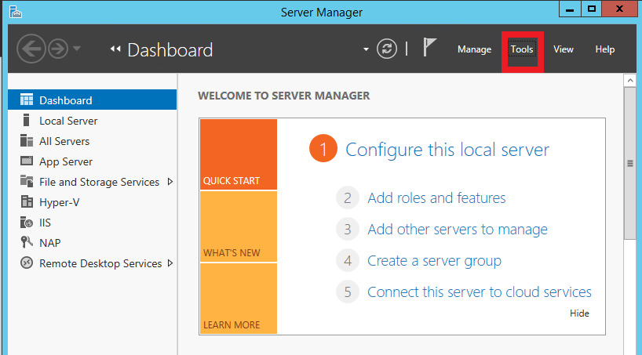

Then select “IIS Manager” from the list

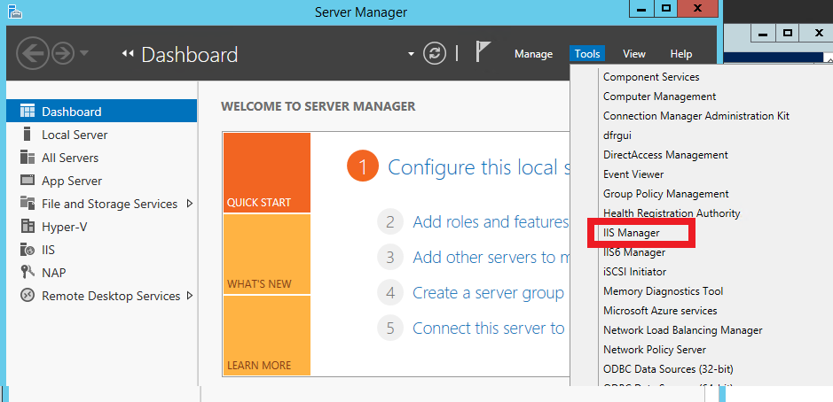

Highlight the IIS Root and Click “Stop” on the link in the right action panel

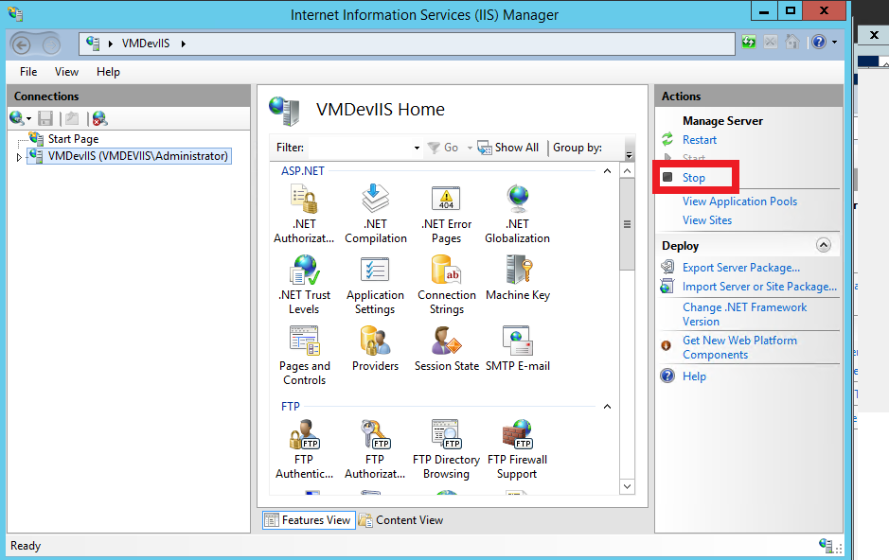

1. Unzip the contents of the Deployment package (UACPortal_ Release v2.7.d.e2.zip and Documents_Release v2.7.d.e2.zip) in to a temporary folder [unzipped temporary folder].
2. Back up C:\UACPortal folder
3. Copy all the files and folders from [unzipped temporary folder]\UACPortal into C:\UACPortal folder and overwrite existing files.
4. Copy following documents from [unzipped temporary folder]\Documents to [FileServer]\UAC_DOCUMENTS\Documents folder
   * UC-Portal-Flyer.pdf
   * UC-Portal-Moving-Flyer.pdf
5. Restart IIS (See below image, click on Restart button)

